M1 - Define scope and Minimum Viable Product

PEI



**Rodrigo Rocha**, 71731

**Rodrigo Relvas**, 71860

**João Pedro**, 80098

**Fábio Nunes**, 80139

**Diana Silva**, 80239

**Susana Dias**, 80410

Mestrado Integrado em Engenharia de Computadores e Telemática

Index

**1 Client side** **3**

1.1 Context and problem 3

1.2 Proposed solution 3

1.3 Features 3

1.4 Overall setup/architecture 4

1.5 Technical requirements 4

1.6 Schedule of features / functionalities release vs milestones 5

1.7 Risks and issues 6

1.7.1 Risks 6

1.7.2 Issues 6

**2 Personas and goals** **7**

**3 Architecture** **8**

**4 Tests and validation** **8**

**5 Manual** **9**

# 

# 1 Client side

## 1.1 Context and problem

The work at the wine cellar consists in evaluate the vats and control values via a central dashboard. The main problem is when some employer needs to control the values of a specific vat when he is near them and not in the office near the dashboard. This would make the employer go to the office look for that specific vat in the system and see the values and probably go back to the vat. This is the problem that we need to solve thus simplifying and saving time to the employees.

## 1.2 Proposed solution

The proposed project aims at an easy way for wine producers and their employees to control their data via a smartphone application that they can directly connect to each wine barrell with a QR Code that pairs with a smartphone via Bluetooth Low Energy. This application can predict the best time to collect samples or predict the ideal time of fermentation process. The employees can also set an alarm to remind them of tasks they have to do on certain vat and also take notes of what they need to control or to remember later. They can also finish the process in order to terminate the communication with the sensor.

## 1.3 Features

1. Portability
   1. Decentralized system that can be used within the bluetooth range.
2. Pairing
   1. Feature designed to guarantee direct connectivity with wine barrel sensor that operator require collect samples.
3. Add note
   1. Operator can take notes about state of the process of fermentation (collect samples).
4. Add alarm
   1. Operator can set alarm to remind them of tasks they have to do on certain time.
5. Finish process

## 1.4 Overall setup/architecture

On the client side you will need to have a smartphone with Bluetooth capacities, in order to read QR Code and pair with a sensor.

## 1.5 Technical requirements

* 1 x SmartBang (Temperature and Density sensor with BLE capabilities);
* 1 x IOS system with BLE capabilities;
* 1 x Android system with BLE capabilities;
* 1 x Office with 4 tables, 8 chairs and WiFi;
* 1 x Linux based system with:
  + Rest;
  + Internet Access;
  + Arduino IDE;
  + AMQP;
* 1 x USB A / micro USB B cable

## 

## 

## 1.6 Schedule of features / functionalities release vs milestones

|  |  |  |  |
| --- | --- | --- | --- |
| **Week** | **Date** | **Milestone** | **Notes** (What we propose to do) |
| 1 | 2019/2/13 | **-** | **-** |
| 2 | 2019/2/20 | **-** | Project selection |
| 3 | 2019/2/27 | **-** | Project research about BLE, Data Processing techniques and Application level design and implementation |
| 4 | 2019/3/06 | **-** | Milestone 1 (Paper Document) and continuous project research |
| 5 | 2019/3/13 | **M1** | Refine Milestone 1(Paper Document) and further research about all technologies used |
| 6 | 2019/3/20 | **-** | Application Prototype Ready |
| 7 | 2019/3/27 | **-** | Minimal BLE system implemented |
| 8 | 2019/4/03 | **M2** | Integrate Application Prototype with BLE System (Milestone 2) |
| 9 | 2019/4/10 | **M3** | Milestone 3 (Paper Document) |
| 10 | 2019/4/17 | **-** | Improve Application |
| 11 | 2019/4/24 | **-** | Improve BLE system protocol usage and security concerns |
| 12 | 2019/5/01 | **-** | Implement data processing techniques on the data recovered from the sensors |
| 13 | 2019/5/8 | **M4** | Integrate all systems and data processing techniques in one unique prototype(Milestone 4) |
| 14 | 2019/5/15 | **-** | Rectify bugs that might be found and improve all integrated systems |
| 15 | 2019/5/22 | **M5** | Prepare full system demonstration(Milestone 5) |
| 16 | 2019/5/29 | **-** | Rectify bugs that might be found and improve all integrated systems |
| 17 | 2019/6/4 | **M6** | Milestone 6(Paper Document) |
| 18 | 2019/6/12 | **M6** | Students@DETI ( Specification + Code) |

## 1.7 Risks and issues

### 1.7.1 Risks

* No internet connection;
* Sensor stops working;
* Sensor not calibrated.

### 1.7.2 Issues

* Errors while fetching data due to few readings/ data is not precise enough;
* Making sure phones are powerful enough to run and use the app.

# 2 Personas and goals

Liliana Costa, operator of “Adega de Borba”



Liliana Costa, born on 4th December, 1980, in Benfica, Portugal, lives alone. She’s a very active person, she likes to hang out with her friends, go to parties, wine appreciator and she’s a volunteer at the municipal shelter.

Liliana has a problem in her hip since birth, that causes her uncomfortable pain.

She works at the *Adega de Borba* and her work consists in evaluate the vats, that is a time consumption work and painful for her hip.

Most of the time spent is due to the information she has to write on paper of the vats and then transcribe it to *Excel*.

She needs an application that allows her to save time and her hip.

Scenarios

* Liliana needs to walk around the building to see the changes of the vats with the help of the application she can open the dashboard and see them.
* Liliana needs to control the time to make changes at some vats, she can open the application and set an alarm to know when she needs to go to the vat and make a change at the wine;
* Liliana has to take paper notes of changes watched she can open the application and take notes of the changes she has observed.

# 3 Architecture

# 

# 4 Tests and validation

* Access to the sensor that’s on the vat with the smartphone using the QR Code
* Set the alarm
* Add notes of a vat
* Finish process
* Pairing with the sensor

# 

# 5 Manual

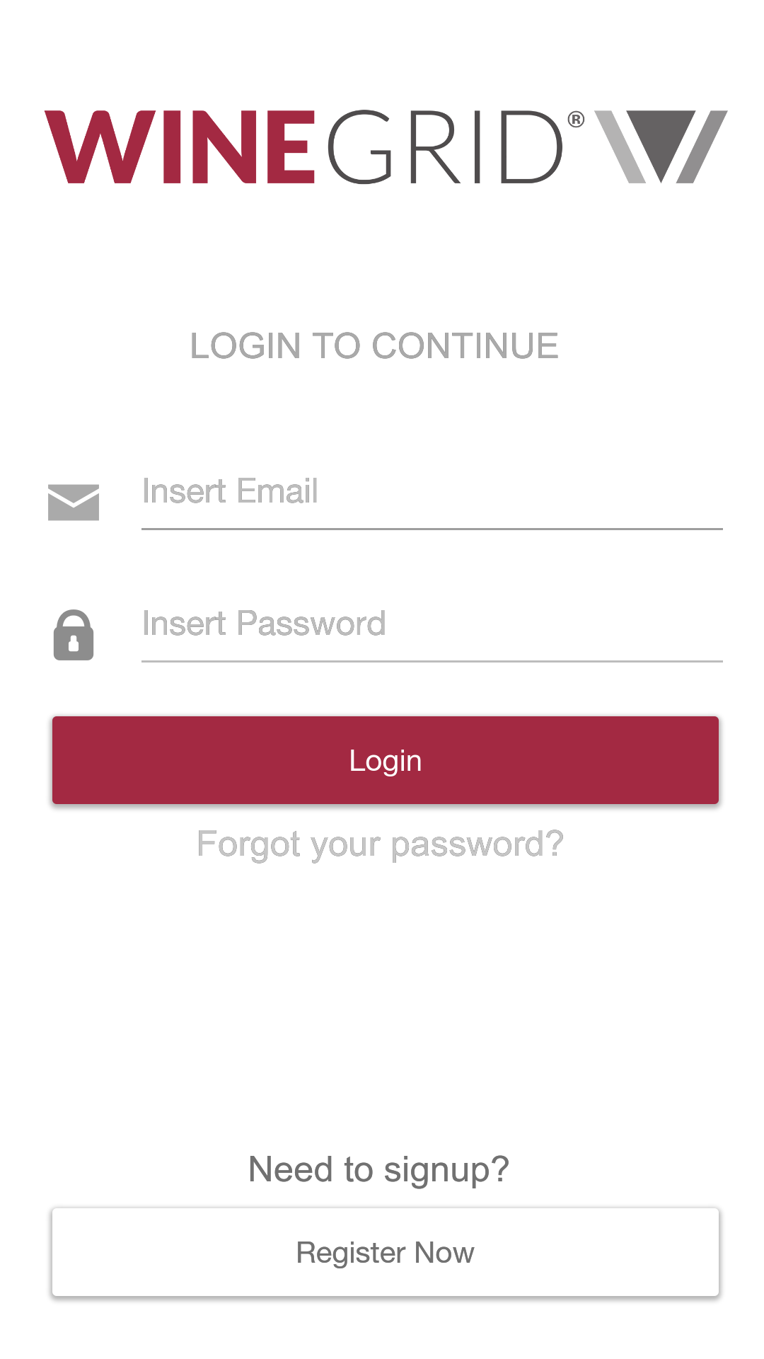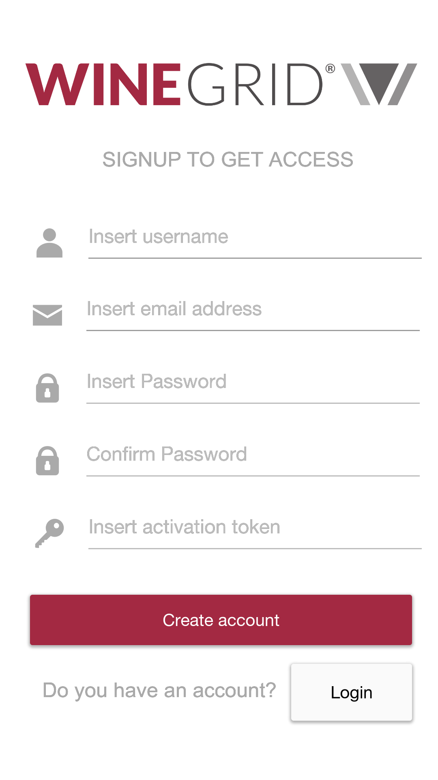

As soon as the user opens the app, is prompted with a option to login or, in case he does not have an account, the option to create one. With a succesful login, the user will arrive at the main page. In this page, he can connect to a certain sensor, via QRCode. This code can be found at the wine vat. The user can also, check the notes he made. In case he doesn’t know what steps to take next, he can get help, by Pressing the “Help” button. A final button named “Exit”, does exactly what it is supposed to do, which is closing the application. The following set of pictures, shows an example of the main and the connecting screen.

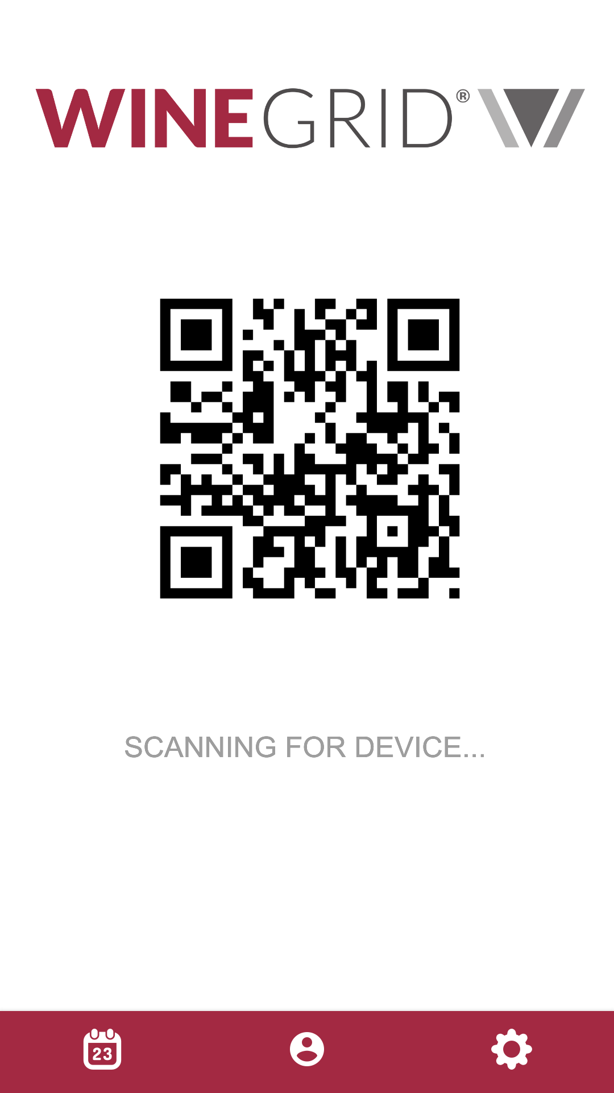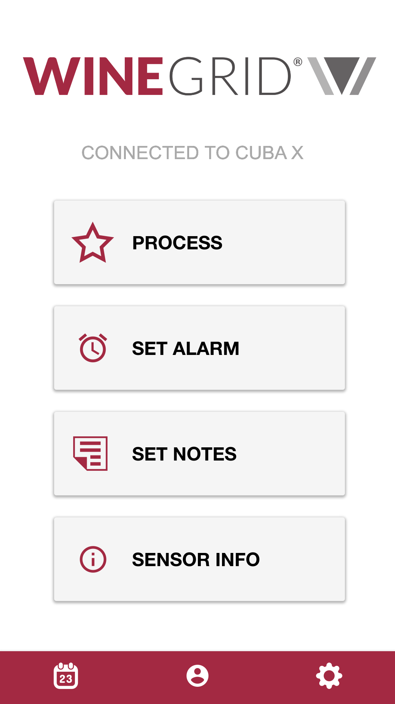

When connecting to a sensor (the user can see what sensor he is connected to on the top of the screen), he can check the processes of that sensor, set and see alarms, see notes and the information relative to the sensor itself.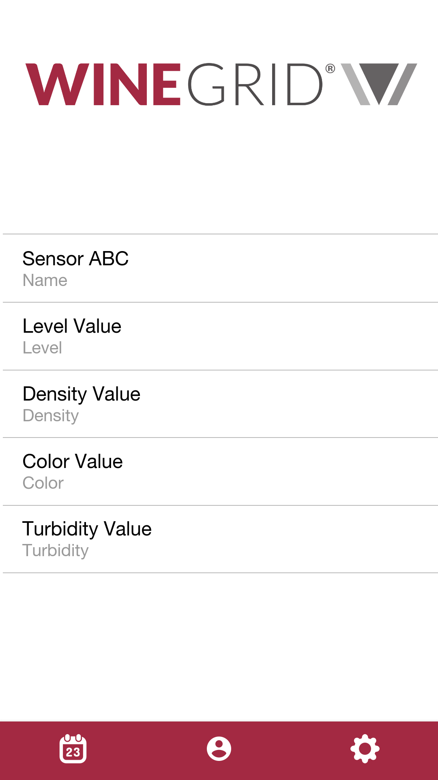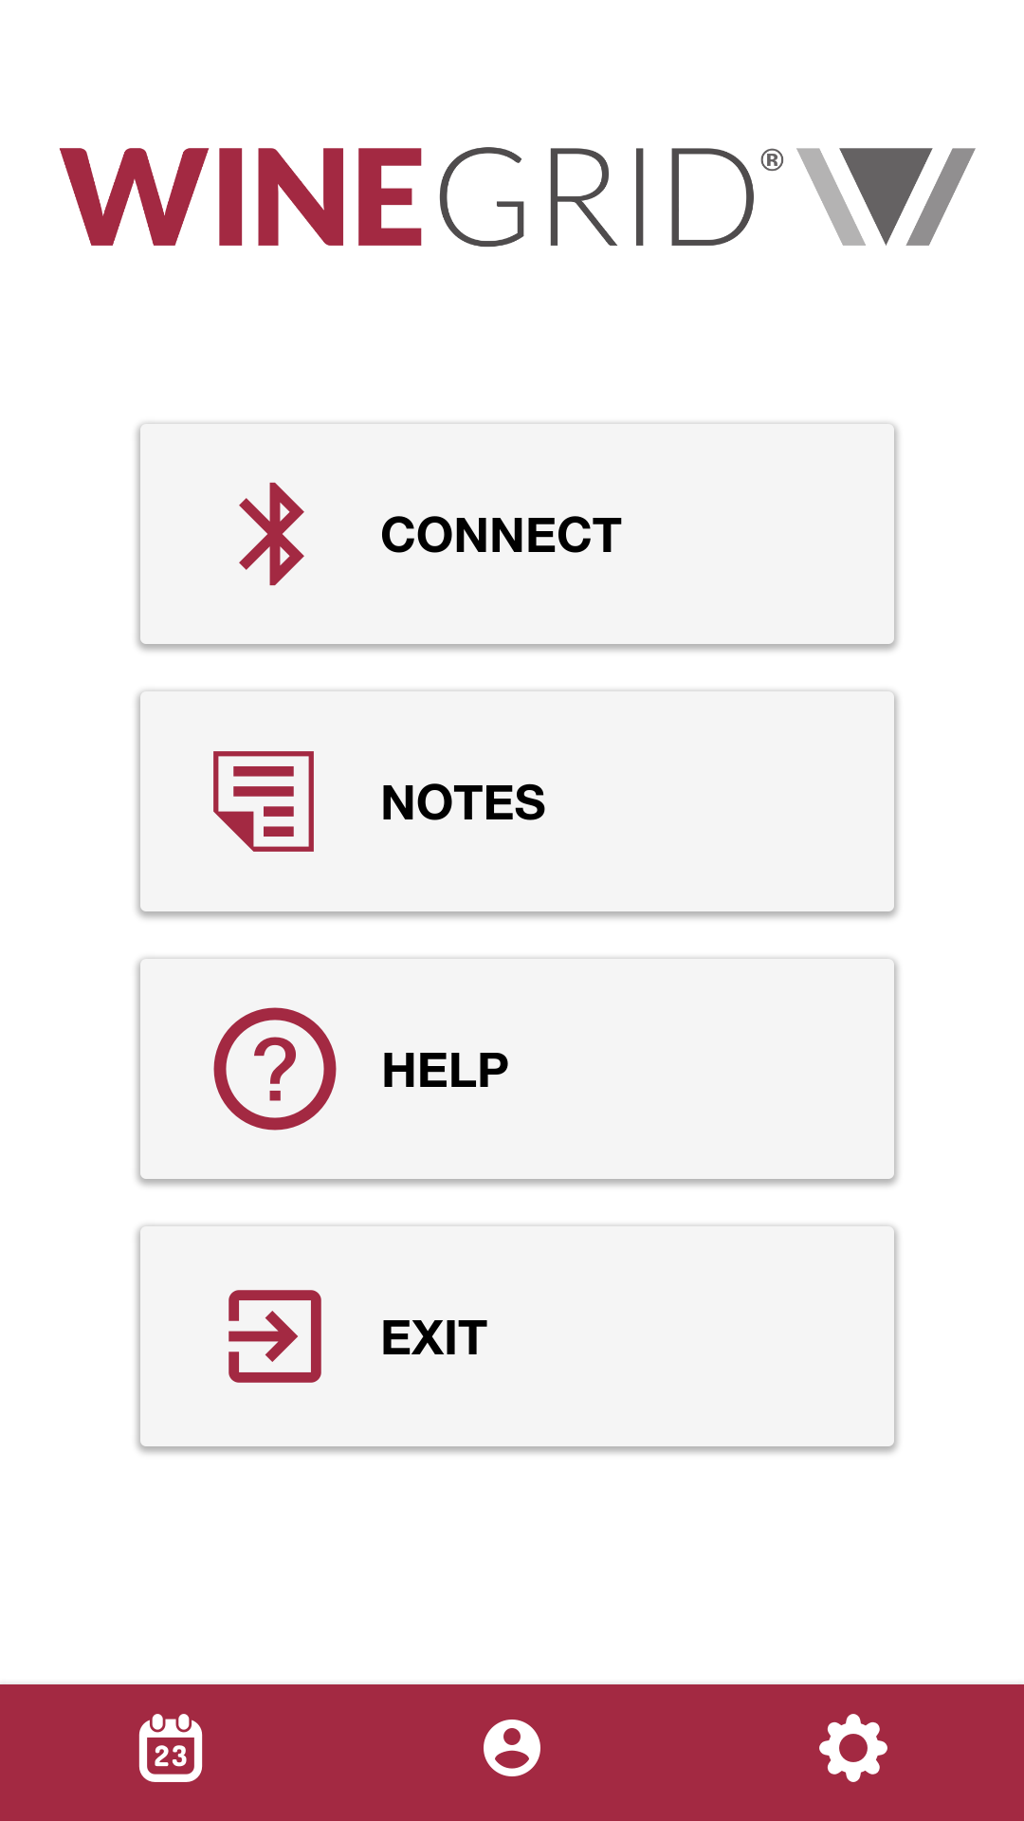

The user can check the processes by choosing the type of process he wants, either fermentation, level, turbidity, and so on. Choosing one, all the processes relative to that type, will be shown and the user can select one and all the information of the process is presented. Then, he can get further details of the process or finishing the process (if it is still running).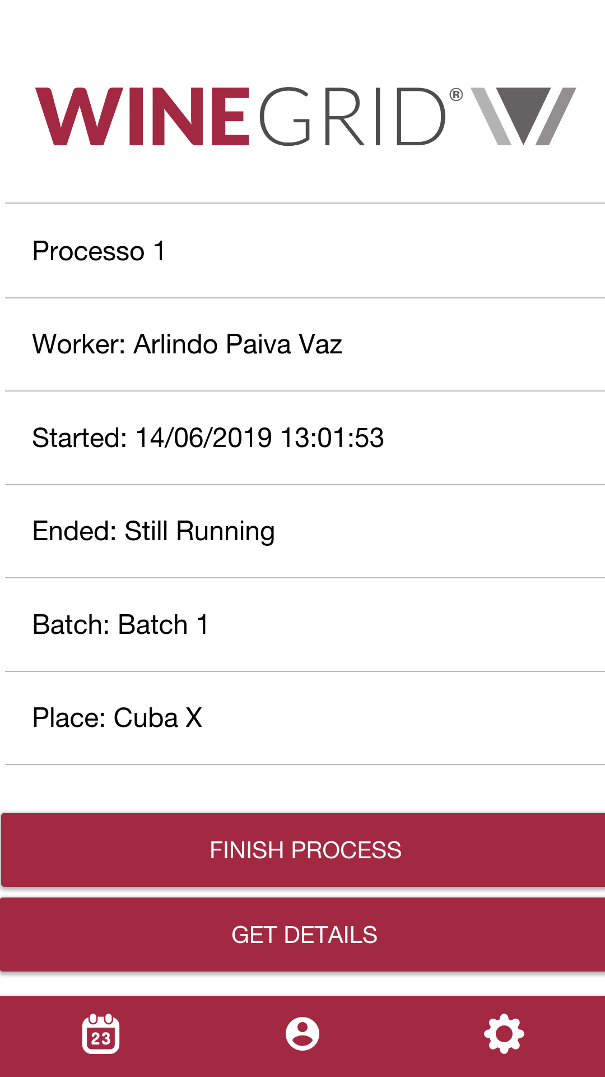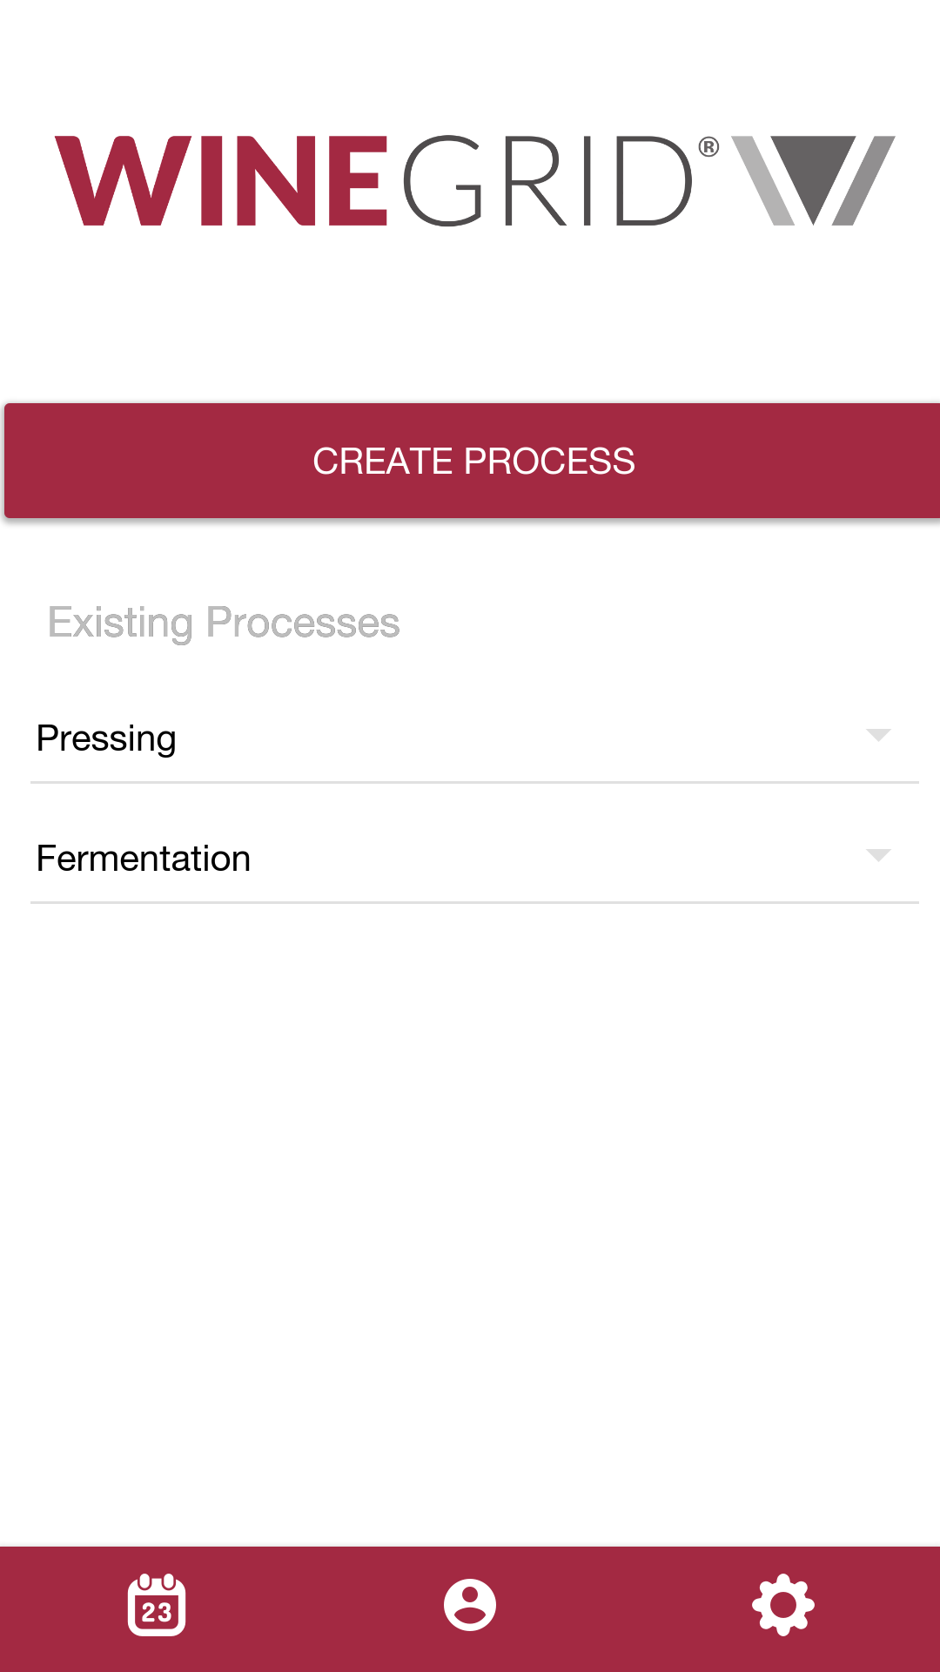

The user, can also create processes. 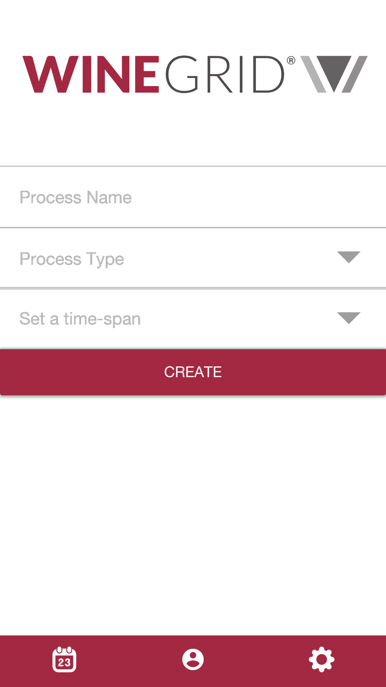

The notes are similar to the processes in terms of accessibility. The user can create, delete and get details of the selected note. The following set of pictures, represent how the user can accomplish this. 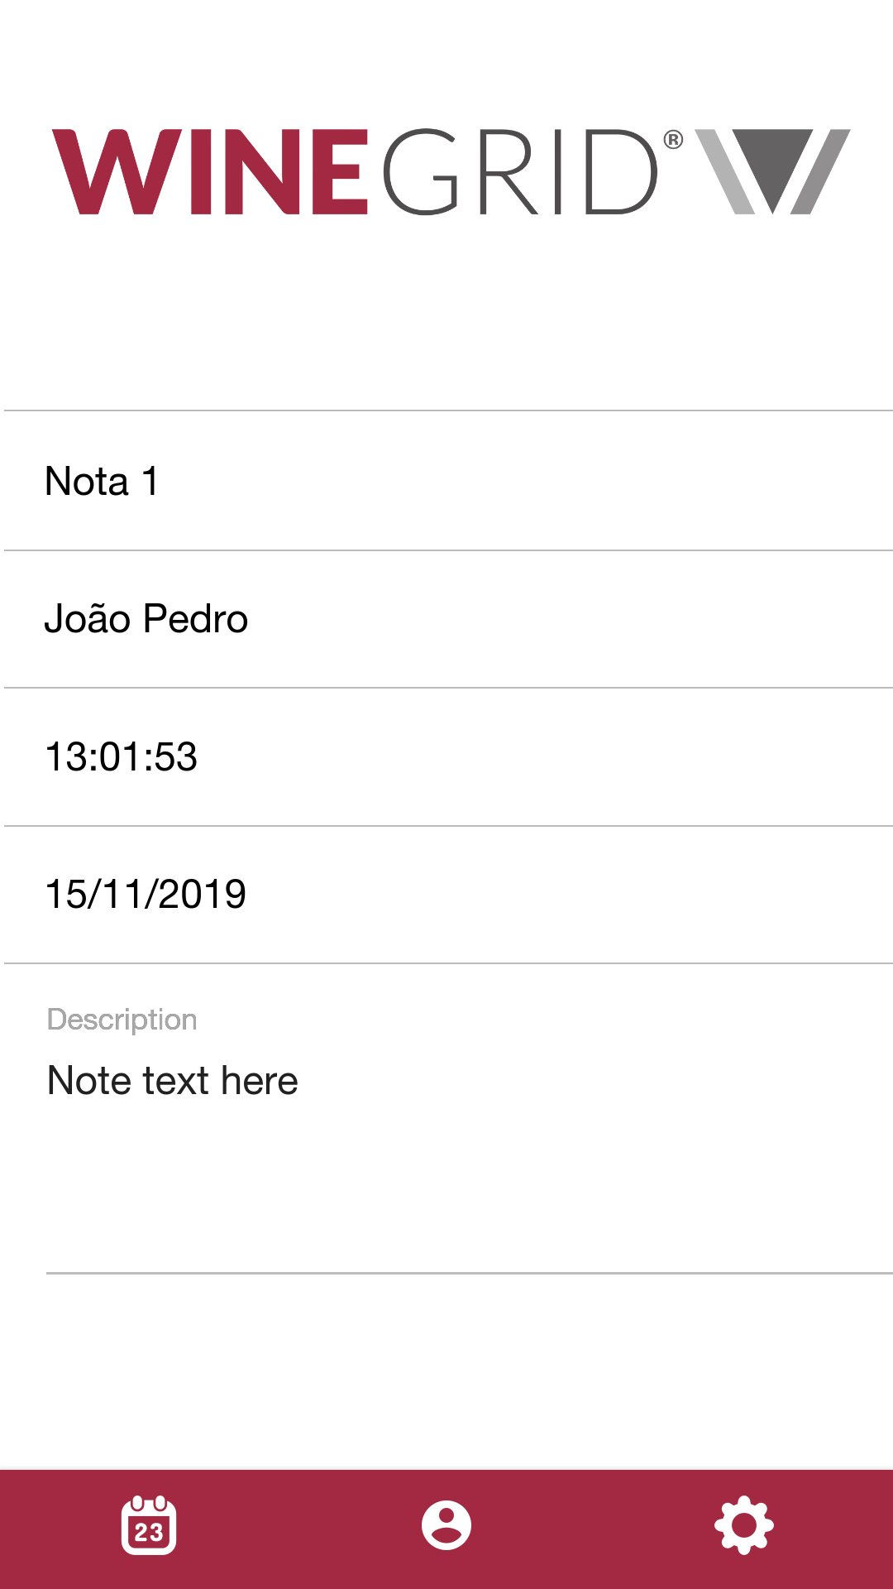

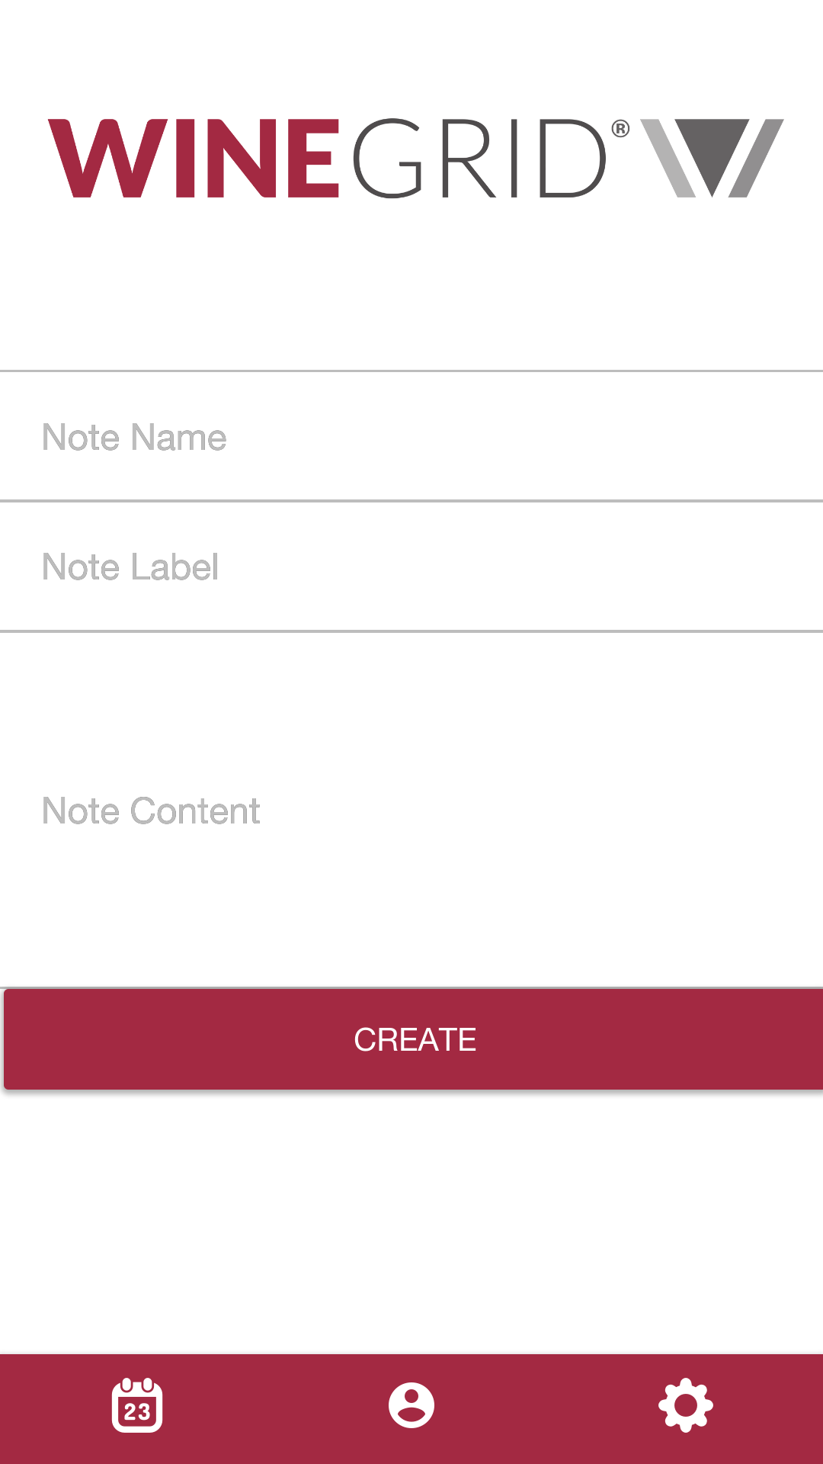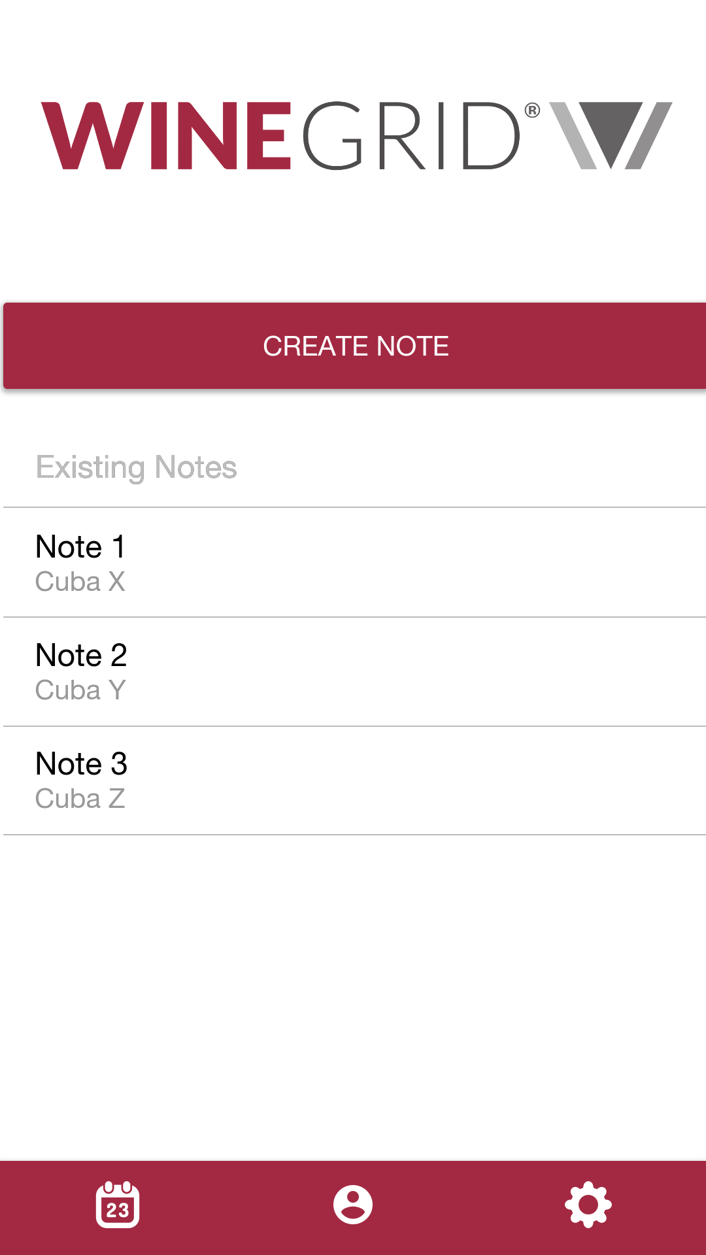

In case there’s no active processes or notes, this information will be displayed.

